Travis Donoghue - CSC 555 Mining Big Data
Assignment 3
- MapReduce:

  - Describe how to implement the following query in MapReduce
SELECT SUM(lo_extendedprice)
FROM lineorder, dwdate
WHERE lo_orderdate = d_datekey
AND d_yearmonth = 'Jan1994'
AND lo_discount BETWEEN 5 AND 7;

MAP1 – From the “lineorder” file – lo_extendedprice
MAP2 – From the “dwdate” file – d_datekey
REDUCER – lo_orderdate or d_datekey, d_yearmonth = ‘Jan1994’, lo_discount BETWEEN 5 AND 7
MAP 3 – Lo_extendedprice
REDUCER – SUM(lo_extendedprice)

  - SELECT d_month, COUNT(DISTINCT d_sellingseason)
FROM dwdate
GROUP BY d_month
ORDER BY COUNT(DISTINCT d_sellingseason)

MAP1 – From the “dwdate” file – d_month, d_sellingseason
REDUCER – (DISTINCT d_sellingseason)
MAP2 – d_month, d_sellingseason
REDUCER – d_month, COUNT(d_sellingseason)

- Consider a Hadoop job that processes an input data file of size equal to 85 disk blocks (85 different blocks, you can assume that HDFS replication factor is set to 1). The mapper in this job requires 2 minutes to read and fully process a single block of data. Reducer requires 1 second (not minute) to produce an answer for one key worth of values and there are a total of 5000 distinct keys (mappers generate a lot of key-value pairs, but keys only occur in the 1-5000 range for a total of 5000 unique entries). Assume that each node has a reducer and that the keys are distributed evenly.

  - How long will it take to complete the job if you only had one Hadoop worker node? For the sake of simplicity, assume that that only one mapper and only one reducer are created on every node.
(1 Node)(2 Minutes)(85 Blocks) + [(1 second)(5000 Keys)/(60 seconds)] =
170 Minutes + 83.333 Minutes = 253.33 Minutes = 4.22 Hours

  - 30 Hadoop worker nodes?
(1/30 Node)(2 Minutes)(85 Blocks) + [(1 second)(5000 Keys)/(30 Nodes)/(60 seconds)]
6 Minutes + 2.77 Minutes = 8.77 Minutes

  - 50 Hadoop worker nodes?
(1/50 Node)(2 Minutes)(85 Blocks) + [(1 second)(5000 Keys)/(50 Nodes)/(60 seconds)]
4 Minutes + 1.66 Minutes = 5.66 Minutes

  - 100 Hadoop worker nodes?
(1/100 Node)(2 Minutes)(85 Blocks) + [(1 second)(5000 Keys)/(100 Nodes)/(60 seconds)]
2 Minutes + .83 Minutes = 2.83 Minutes

  - Do you expect the introduction of the combiner affect the runtime of this job? Why or why not? (no credit for a “yes/no” answer, you have to explain).
No. The reason is because the key values are all unique and a combiner is only useful if the values are not unique. The combiner would then be a “mini-reducer”, reducing the same keys to an N value.

  - Would changing the replication factor have any affect your answers for a-d?
  - No, replication will only replicate the blocks after they are processed having no effect on the time it takes for the first blocks to be processed.

You can ignore the network transfer costs as well as the possibility of node failure.

  - Suppose you have a 6-node cluster with replication factor of 3. Describe what MapReduce has to do after it determines that a node has crashed while a job is being processed. For simplicity, assume that the failed node is not replaced and your cluster is reduced to 5 nodes. Specifically:

    - What does HDFS (the storage layer) have to do in response to node failure in this case?
In response to a node failure, the HDFS will have copies of any blocks that were created on the node. The name node will also eventually determine that the node has failed, and will then move any remaining blocks not finished onto another working node within the cluster.

    - What does MapReduce engine have to do to respond to the node failure? Assume that there was a job in progress because otherwise MapReduce does not need to do anything.
The MapReduce engine will receive a signal that there were blocks that were not finished on the failed node. The blocks that were not finished will then begin the MapReduce process again until the block is completed and copied on HDFS.

  - Where does the Mapper store output key-value pairs before they are sent to Reducers?

The key is stored within the memory buffers which then falls into the local file system of the TaskTracker node tha tis running the mapper.

- Using the SSBM schema (http://rasinsrv07.cstcis.cti.depaul.edu/CSC555/SSBM1/SSBM_schema_hive.sql) load the Part table into Hive (data available at http://rasinsrv07.cstcis.cti.depaul.edu/CSC555/SSBM1/part.tbl)

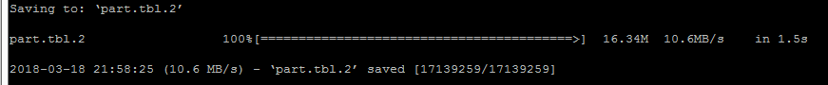

create table part (
p_partkey int,
p_name varchar(22),
p_mfgr varchar(6),
p_category varchar(7),
p_brand1 varchar(9),
p_color varchar(11),
p_type varchar(25),
p_size int,
p_container varchar(10)
) ROW FORMAT DELIMITED FIELDS TERMINATED BY '|' STORED AS TEXTFILE;

NOTE: The schema above is made for Hive, but by default Hive assumes ‘\t’ separated content. You will need to modify your CREATE TABLE statement to account for ‘|’ delimiter in the data.

Use Hive user defined function (i.e., SELECT TRANSFORM from Lecture4, weekday mapper is available here: http://rasinsrv07.cstcis.cti.depaul.edu/CSC555/weekday_mapper.py) to perform the following transformation on Part table (creating a PartX table): in the 2nd column/p_name swap the two words in the column. For example, rose moccasin would become moccasin rose or honeydew dim would be dim honeydew. Your transform python code (split/join) should always use ‘\t’ between fields even if the source data is |-separated.

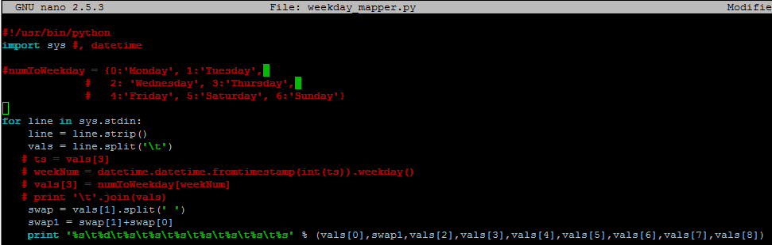

Load data into the tab
LOAD DATA LOCAL INPATH '/home/ec2-user/part.tbl.2'
OVERWRITE INTO TABLE Part;

Pull the first 5 rows to insure the data is in the table.
Select * FROM part limit 5;
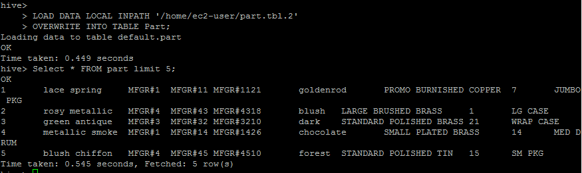

add FILE weekday_mapper.py;
INSERT OVERWRITE TABLE Part
SELECT TRANSFORM (p_partkey, p_name, p_mfgr, p_category, p_brand1, p_color, p_type, p_size, p_container) USING 'python weekday_mapper.py' AS (p_partkey, p_name, p_mfgr, p_category, p_brand1, p_color, p_type, p_size, p_container) FROM Part;

It kept crashing and I couldn’t figure it out…
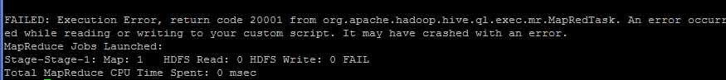

- Download and install Pig:
cd
wget http://rasinsrv07.cstcis.cti.depaul.edu/CSC555/pig-0.15.0.tar.gz
gunzip pig-0.15.0.tar.gz
tar xvf pig-0.15.0.tar

set the environment variables (this can also be placed in ~/.bashrc to make it permanent)
export PIG_HOME=/home/ec2-user/pig-0.15.0
export PATH=$PATH:$PIG_HOME/bin

Use the same vehicles file. Copy the vehicles.csv file to the HDFS if it is not already there.

Now run pig (and use the pig home variable we set earlier):
cd $PIG_HOME
bin/pig

Create the same table as what we used in Hive, assuming that vehicles.csv is in the home directory on HDFS:

To place the vehicles.csv file where PIG can retrieve it
hadoop fs -put ../vehicles.csv /user/ec2-user/

VehicleData = LOAD '/user/ec2-user/vehicles.csv' USING PigStorage(',')
AS (barrels08:FLOAT, barrelsA08:FLOAT, charge120:FLOAT, charge240:FLOAT, city08:FLOAT);

You can see the table description by
DESCRIBE VehicleData;
Verify that your data has loaded by running:

VehicleG = GROUP VehicleData ALL;
Count = FOREACH VehicleG GENERATE COUNT(VehicleData);
DUMP Count;

How many rows did you get? (if you get an error here, it is likely because vehicles.csv is not in HDFS) 34,174

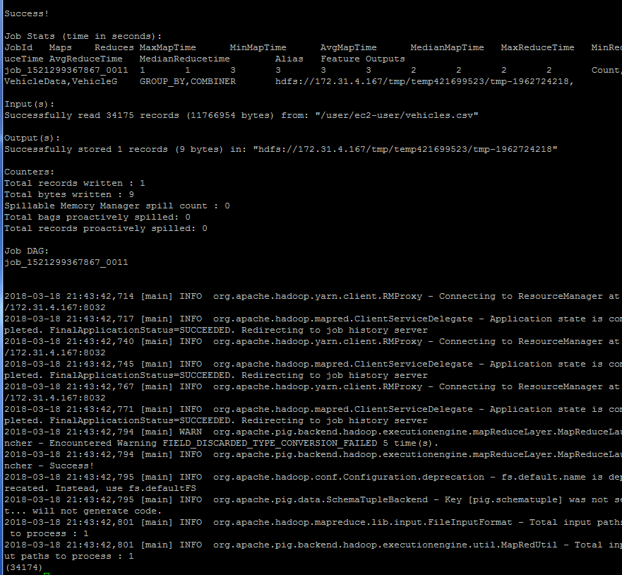
Create the same ThreeColExtract file that you have in the previous assignment, by placing barrels08, city08 and charge120 into a new file using PigStorage .You want the STORE command to record output in HDFS. (discussed in p457, Pig Chapter, “Data Processing Operator section)
NOTE: You can use this to get one column:

OneCol = FOREACH VehicleData GENERATE barrels08;

ThreeColExtract = FOREACH VehicleData GENERATE barrels08, city08, charge120;
D = LIMIT ThreeColExtract 10;
Dump D;
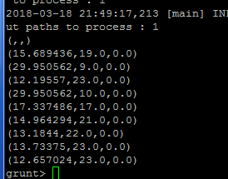

Describe ThreeColExtract; Store ThreeColExtract INTO 'Assignment3' USING PigStorage ('\t');

Verify that the new file has been created and report the size of the newly created file.
(you can use quit to exit the grunt shell)

To verify the file is there (leave pig first)
hadoop fs -ls /user/ec2-user/Assignment3

The size of the file is 627,867

Submit a single document containing your written answers. Be sure that this document contains your name and “CSC 555 Assignment 3” at the top.

